Change #1 - In files - DataProfile1.java and DataProfile2.java, Copy and paste this line after number of Rooms

**public** **static** String *numberOfChildren*;

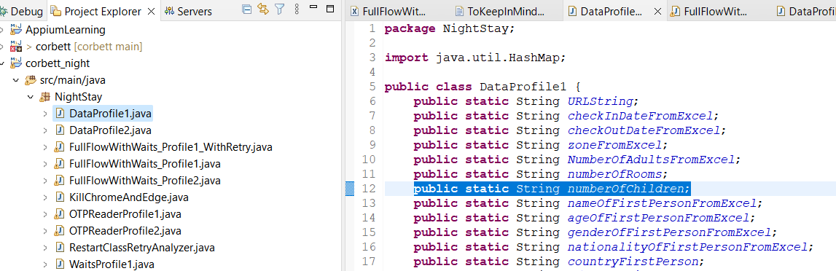

Change #2 – In files - DataProfile1.java and DataProfile2.java , Copy and paste this line after number of Rooms

*numberOfChildren* = test.get("numberOfChildren");

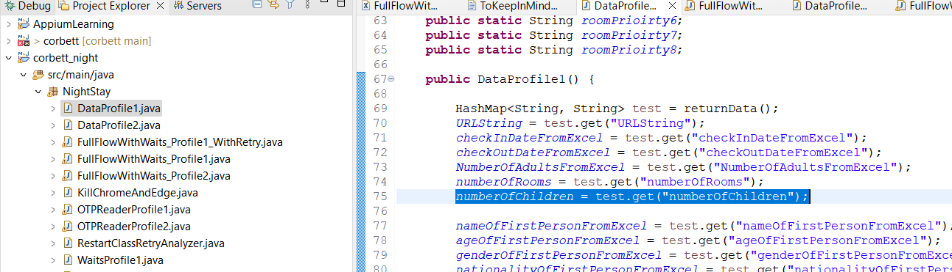

Change #3 – In files - DataProfile1.java and DataProfile2.java , Copy and paste this line after number of Rooms

map1.put("numberOfChildren", "2");// valid values are "0", "1","2"

